**Project Synopsis**

**Chapter: 1**

**SYNOPSIS**

**1.1 Title:** “Electronic Bid”-An ONLINE AUCTION SYSTEM

**1.2 Introduction**

An auction is a process of [buying and selling](https://en.wikipedia.org/wiki/Trade) [goods](https://en.wikipedia.org/wiki/Good_(economics)) or [services](https://en.wikipedia.org/wiki/Service_(economics)) by offering them up for [bid](https://en.wikipedia.org/wiki/Bidding), taking bids, and then selling the item to the highest bidder.

The global reach of Online Auction system allows for the buyers and sellers to overcome geographical constraints and purchase products anytime from anywhere over the internet. The Online auction system provides the consumers with great advantages of low prices, greater product selection and greater efficiency compared to the usual traditional auctioning system.

To perform auction of an item the auctioneer must be logged in and upload the picture and information about the item. The auctioneer has to set a primary or starting price, from that price the users can bid. No one can bid at the low price than the auctioneer set up. Then the image of product will be appeared in the browser window and other user can see the picture and bid it. The highest bidder can get the item by paying. Product delivery may be home delivery or hand to hand delivery. If the user wants home delivery he has to pay vehicle cost. Without login users can only search for the items and can view the information, but in order to bid they need to login.

* 1. **Objectives of the Project**

The auction site acts as open forum were buyers and sellers can come together an exchange their products. The site makes sure that the seller gets a fair deal and buyers get a required product. This allows user to list items for sale and other user to bid on them in auctions.

Our main goal is to make a website of Online auctioning for the people who can perform auction of items through internet. We aim to achieve the objective through:-

* An ethical bidding environment for our customer.
* Accurate product and pricing information.
* Quick response to customer enquiries and problems.
* Highest standards for customer’s privacy.
* Long term relationship with supplier and partners.

**1.4 Project category:**

The project comes under the category of Web Based Application.

* 1. **Language tools:**
* User Interface Design: HTML5, CSS3, JavaScript

HTML5: It is a Markup Language used for structuring and presenting content on the World Wide Web.

CSS3: CSS3 (Cascading Style Sheet)is the latest standard for CSS.CSS3 is a language for describing the presentation of web pages including color.

JavaScript: It is commonly used as a Client-Side Scripting language. This means that JavaScript code is written into a HTML page.

* Server-side Scripting: PHP

PHP: PHP is a Server-Side Scripting language designed for web development but also used as a general purpose programming language.

* Backend: MYSQL Server

MYSQL: MYSQL is an open source database management system. It uses a structured query language.

**1.5.1 Hardware requirements:**

* Processor : Intel Dual core or any higher version
* RAM : 2 GB and above
* Hard Disk Utilization : 40 GB and above
* Input Devices : Mouse, Keyboard, etc
* Output Devices : Monitor, Printer, etc
* Operating System : Windows 7, Windows 8, Windows 10

**1.5.2 Software requirements:**

* Text Editor : Sublime Text 3 or any other text editor
* Server Software : WAMP SERVER 2.4
  1. **Structure of the program:**

**Analysis:**

Bidding activity is one of the most important transactions in online auction sites and trends within bidding activity can be used to design business-oriented metrics and resource management techniques specific to online auction sites. This software provides an analysis of bidding activity of online auction sites including

1. Popularity of bidders, sellers and winners.
2. Bidding activity within different auction price ranges.
3. Arrival rate of new bidders and bidding activity within groups of auction with the same unique number of bidders.

**Module Description:**

Users are of three types:

1. Admin
2. Seller
3. Bidder

**Admin:**

The main function of the admin is to manage the smooth progression of the online auction as a whole.

The administrator mainly does:

* Admin can manage Products.
* Admin can manage Users.
* Admin can manage Bidding.
* Admin can manage Package.
* Admin can manage Payments.
* Admin can manage Winners list.
* Admin can manage News.
* Admin can generate the whole system work report.
* Admin will manage the feedback sent by Bidder.

**Seller:**

Here the seller can view his own bidding details, Purchase report, auction winning report, etc.

The user mainly does:

* Seller can upload the auction product.
* Seller can set the starting prize of an item.
* Seller can view the Winners list.
* Bidder can purchase package.
* Seller can respond to the query sent by Bidder.

**Bidder:**

This module is for the buyer or the product bidder who can see the list of products up for bidding and place his/her bid on the product.

* Bidder can search for the items.
* Bidder can view the details of the product.
* Bidder can also modify the bidding prize.
* Bidder can send the Feedback.
* Bidder can send the query.
* Bidders can view the news.
  1. **Future Scope**
* The future scope of the project is to take the auctioning system to a worldwide platform.
* Companies can avoid financial losses on sales items by setting the minimum bid price high enough to cover cost.
* In future this web application can be turned into a mobile application.

**Software Requirement Specification**

**Chapter: 2**

**SOFTWARE REQUIREMENT SPECIFICATION**

## Introduction:

Software Requirement Specification is a document that completely describes what the proposed software should do without describing how the software will do it. The basic purpose of SRS is to bridge the communication gap between the parties involved in the development of the software. SRS is a medium through which the client and user needs are accurately specified. A good SRS should satisfy all the parties- something very hard to achieve- and involves trade-offs and persuasion. Another important purpose of developing an SRS is helping the users understand their own needs.

**The main advantages of SRS are:** It establishes the basis of agreement between the client and the supplier on what the software product will do. It provides a reference for validation of the final product.

**2.1.1 Purpose:**

The main purpose of this project is people invest their money to get maximum profit and knowledge about our Online trading system. Here all type of user can go and analyses the data of different field and get maximum profit for future investment.

**2.1.2 Scope:**

The Project investigates the entry threshold for providing a new auction service channel via the real options approach, where the entry threshold is established by using an Online auctioning system designed for the use of normal users (individuals), Industrialists, Entrepreneurs, Organizations and Academicians under transaction rate uncertainty.

**2.1.3 Definitions, Acronyms, Abbreviations:**

1. **DFD:** Data Flow Diagram.
2. **ADMIN:** The Administrator.
3. **CFD:** Context Flow Diagram.
4. **PHP:** Hypertext Pre-processor.
5. **SQL:** Structured Query Language.
6. **IEEE:** Institute of Electrical and Electronic Engineering.

**2.1.4 References:**

**Books:**

* Pankaj Jalote, An integrated approach to software engineering, ed. 3 ,

Publication: Narosa Publishing House.

* Nixon (Robin), Learning PHP MySQL and JavaScript,

Publication: Shroff publishers & Distributors Pvt Pankaj Jalote Ltd.

**Website:**

* http://[www.ebay.in](http://www.ebay.in)
* http://[www.w3schools.com](http://www.w3schools.com/)
* https://www.slideshare.net
* https://www.listia.com

**2.1.5 Overview:**

This system provides an easy solution to users to buy or sell their product with maximum profit online. SRS includes two sections Overall description and Specific requirement.

* Overall description will describe major role of the system components and interconnections.
* Specific requirements will describe roles & functions of the users.

**2.2 Overall Description:**

This section will contain information about the project as a whole including perspective & constraints.

**2.2.1 Product Perspective:**

The Online auction system is an independent system. This system involves two users i.e., buyer and seller. The Database connection is provided online to make faster and easy access to data retrieval.

**2.2.2 Product Functions:**

* Customer must have a valid User Id and Password to login to the system.
* If there is a new user he has to register for this auction process.
* User can search for the product he wants.
* User can bid for the product before the date when the product gets expired.
* Administrator can take a backup of the database for every auction that is happening periodically.
* All users are authenticated to avail the services.

**2.2.3 User Characteristics:**

* User should have basic Knowledge about Computers.
* User should be familiar with internet.
* No prior knowledge about PHP is required.
* No prior knowledge about database management is required.
* This is basically a multiple user system, with different login id and password.

**2.2.4 General constraints:**

* This application can be installed in any Operating System.
* Each user must keep their password as confidential.
* Only admin can control user addition and deletion.
* No error condition shall cause the application to exit prematurely.
* The users access the online auction system from any computer that has internet browsing capabilities and an internet connection.

**2.2.5 Assumptions and Dependencies:**

* This system can be used only if the user login with correct User Id and password.
* The future transaction can be carried on only with the permission of the administrator.
* The Administrator should be careful while modifying or deleting any data which will cause inconsistency in the database.
* There is only one Administrator.
* The code should be free with compilation errors/syntax errors.

**2.3 Specific Requirements:**

**2.3.1 External Interface Requirements:**

The external interface should be an interactive interface. The interface should be simple and easy to use. It should allow the administrator to login the system and perform appropriate operations.

**2.3.1.1 User Interfaces:**

There are two types of users for this system. One is Seller and other is Bidder. Both the user’s user interface will be graphical user interface. The graphical user interface mainly consists of Hyperlinks, data entry fields such as the email Id field, password, etc. The user interface for the software shall be compatible to any browser such as Internet Explorer, Mozilla or Netscape Navigator by which user can access to the system.

**2.3.1.2 Hardware Interfaces:**

* Processor : Intel Dual core or any higher version
* RAM : 2GB and above
* Hard disk Utilization : 40GB and above
* Input Devices : Mouse, Keyboard
* Output Devices : Monitor, Printer

**2.3.1.3 Software Interface:**

* Operating system: Win 7/8/10.
* Browser: Internet Explorer, Google chrome, Mozilla Firefox.
* Application Server: Wamp Server.
* Other Software: Sublime Text Editor.
* Language: PHP 5.4
* Database (Back End):My SQL
* Web components:HTML5, CSS

**2.3.1.4 Communication Interface:**

The main communication protocol will be Hyper Text Transfer Protocol (HTTP). This will be used to transfer information back and forth from the client to the server. HTTP GET & POST will be used to send the information securely over the web browser.

**2.3.2 Functional Requirements:**

**2.3.2.1 Module 1:**

**Admin Module:** Admin can manage the users as well as Admin can generate the reports of the users.

* **Manage Users:** The Administrator assigns new users when a new client joins the online auctioning. Also he can delete an account when any of the users leave the auctioning organization.
* **Category Management:** This module provides all facilities to admin for managing the different product category.
* **Manage Package:** An Admin can add or delete the packages as and when required, which the seller purchases in order to add the product for bid.
* **Manage Products:** An Admin can host the products when seller requests.
* **Generate Reports:**  The Administrator can generate report of Product, users, bidding report, payment & winners report.

**2.3.2.2 Module 2:**

**Seller Module:** Here the seller can upload the product and also can view his own bidding details, purchase report, auction winning report, etc.

* **Login:** Login module includes various utilities like User registration, Authentication, Change password and Forgot password.
* **Add Product:** Seller can add a product. He will specify the product name, select category, minimum bid price and description. An image of the product can also be uploaded for the bidders who want to buy the product.
* **Edit Product:** Seller will be able to edit information of an uploaded product.
* **View winners list:** The seller can view the winners list.

**2.3.2.3 Module 3:**

**Bidder module:** This module is for the buyer or the product bidder who can see the list of products up for bidding and place his/her bid on the product.

* **Login:** Login module includes various utilities like User registration, Authentication, Change password and Forgot password.
* **Search:** Search module helps the user to search the product they want.
* **Bid module:** User can bid his desired products. If the bidder wants to bid a product he must bid with a higher amount than the last bid.
* **View details:** Users can view the details of the product such as, product name, minimum prize of the product, product image and other information about the product.
* **Feedback:** Bidder can send the feedback or satisfaction of bidding and based on this user may give ratings for different sellers.

**2.3.3 Non-Functional Requirements:**

**2.3.3.1 Performance Requirements:**

* The physical machine to be used in the Online Auction needs to have internet access in order to connect to the database.
* The software shall take initial load time depending on internet connection strength which also depends on the media from which the product is run.
* Queries will return results based on internet connectivity speed.

**2.3.3.2 Design Constraints:**

* Labels, Textboxes, Text area & Dropdown List boxes, Submit Button etc help in selecting user options easily.
* Validation whenever applicable based on the database.
* Keyboard & mouse can be interoperable.
* It has GUI which provides better Look & Feel.

**2.3.4 Other Requirements:**

**2.3.4.1 Safety Requirements:**

* In case the user forgets or loses Password, the repair functionality helps by choosing “forgot password” option in the main login window.
* The online auction system will use the secure authentication for the system administrator. Login Id & Password is associated with the system administrator to provide security over the system.

**2.3.4.2 Security Requirements:**

In this section we will look at the most common security requirements.

* **Fairness:** is properly the most important property required for an auction. Roughly it means that all participants should be treated equally.
* **Confidentiality:** of bids is often seen desirable.
* **Anonymity:** of bidders is often seen desirable.
* **Minimization of trust:** is one party, particularly the auctioneer, is a generally desirable property for any secure system. The trust may be required for different properties, particularly for anonymity and for fairness.
  + - 1. **Software Quality Attributes:**
* Maintainability: This system can be easily maintained, since it is simple to use.
* Availability: Availability of the system is guaranteed for 24*7 hours. Therefore, auction can be conducted at any time.
* Scalability: System can be scaled later according to the requirements of the user. It can be extended to the other departments of the college if necessary.
* Compatibility**:** This System will be Compatible with almost all the web servers.

**System Design**

**Chapter: 3**

SYSTEM DESIGN DOCUMENT

**3.1** **INTRODUCTION**

The purpose of the design phase is to find the solution of the problem specified in the requirement document.The design activity is often divided into separate phases-

System Design is sometimes called as top level design. The aim of the system design is to identify the modules that should be in the system, the specification of this modules and how they interact with each other to produce the desired result. At the end of the system design all the major data structures, file formats and the major modules in the system and their specification are decided.

**3.2** **CFD (LEVEL-0): Context Flow Diagram**

The Context diagram shows the system under consideration as a single high-level process and then shows the relationship that the system has with other external entities. Context diagram is also called as Context-Level Data-Flow Diagram or Level-0 Data Flow Diagram. Since a Context diagram is a specialized version of Data Flow Diagram Context Diagrams and Data-Flow Diagrams were created for systems analysis and design.

A Context diagram is possibly one of the first tools that are applied early in the requirements elicitation process within the Analysis phase of a typical System Development Life Cycle.



**3.3 Data Flow Diagram**

A DFD also known as bubble chart has the purpose of clarifying system requirements and identifying major transformations that will become programs in system design. So it is the starting point of the design phase that functionally decomposes the requirement specification down to the lowest level of details. The DFD consist of bubbles joined by lines.

A Data Flow Diagram (DFD) is a graphical representation of the”flow” of data through an information system, modelling its process aspects. A DFD is often used as a preliminary step to create an overview of the system, which can later be elaborated. DFDs can also be used for the visualization of data processing (structured design).

|  |  |
| --- | --- |
| **SYMBOLS** | **DESCRIPTION** |
|  | Represents the Database |
|  | Represents the external entity |
|  | Represents the data flows    Represents the process that transforms  incoming data flows into outgoing  data flows |
| * | Represents the AND symbol |
| + | Represents the OR symbol |

A DFD shows what kind of data will be input to the system and what data is received as the output. Also it tells where the data will come from and go to and where it is stored in the process ‘DFD can be used to visualize a data processing’. A Data Flow Diagram is a graphical representation of flow of data through information system.

A DFD may look similar to a flow chart. However there is a significant difference with the data flow diagram. The arrows in DFDs show that there is a flow of data between the two components and not that the component is sending the data that must be executed in the following component.

**CONSTRUCTING A DATA FLOW DIAGRAM**

* Process should be named and numbered for easy reference. Each name should be representative of the process.
* The direction of the flow is from top to bottom and from left to right. Data traditionally flows from source to the destination, although they may flow back to the source. One way to indicate this is to draw a long flow line back to a source. An alternative way is to repeat the source symbol as a destination. Since it is used more than once in the DFD, it is marked with a short diagonal in the lower right corner.
* When the process is exploded into lower level details, they are numbered.
* The names of data stores, sources and destination are written in capital letters.
* Process and data flow names have the first letter of each word capitalized.

3.3.1 DFD (LEVEL-1):

**ADMIN**



**SELLER**



**BIDDER**



3.3.2 DFD (LEVEL 2): **ADMIN: Manage product**



**ADMIN: Manage Package**



**BIDDER: Bidding a product**



**Database Diagram**

**Chapter: 4**

DATABASE DESIGN

**4.1 INTRODUCTION**

Database is simply collection of information or data. The first step in assigning a database application is to understand what data is to be stored in the database, what application must be built on it and what operations are frequent and subject to perform requirements.

A database design is an inherent collection of data with some inherent meanings, design, built and populated with data for a specific purpose. The following guide lines are being followed during the database design:

* Description names for the tables, columns, indexes.
* Singular names for tables and columns.
* Proper data type for each column.

The advantages of database are:

* Reduced data redundancy.
* Reduced updating errors and increased consistency.
* Grater data integrity and independence from application programs.
* Improved data access to users through use of host and query languages.
* Improved data security.
* Reduced data entry , storage and retrieval costs
* Facilitated development of new applications program.

**4.2 DATABASE TABLES:**

The database of Auctioning System is organized into following tables:

🡪Admin_login 🡪Bid 🡪Bid_payment 🡪Category 🡪User

🡪Feedback 🡪Mail_us 🡪Hostproduct 🡪Comment 🡪Newsreq

🡪Notification 🡪Package 🡪Payment 🡪Product 🡪 Subcategory

🡪Replyquery 🡪Query 🡪Subscription 🡪Winnerlist

Table: Admin

|  |  |
| --- | --- |
| Username | Password |

Table: User

|  |  |  |  |  |
| --- | --- | --- | --- | --- |
| User_id | Fullname | Address | Contact | User_type |
| Gender | Email | Password | Photo |

Table: Category

|  |  |
| --- | --- |
| Cid | Cname |

Table: Sub-Category

|  |  |  |
| --- | --- | --- |
| Subcid | Cid | Subcategory |

Table: Product

|  |  |  |  |
| --- | --- | --- | --- |
| Prid | ProductName | Cid | Subcid |
| Desc | Image | User_id | Min_range |

Table: Feedback

|  |  |  |
| --- | --- | --- |
| Fid | User_id | Fcontent |
| Fdate | Fcategory |

Table: Package

|  |  |  |  |
| --- | --- | --- | --- |
| Pid | Ptitle | Pamt | Pvalidity |

Table: Subscription

|  |  |  |
| --- | --- | --- |
| Subcid | Pid | Uid |
| Subdate | Enddate |

Table: Query

|  |  |  |  |
| --- | --- | --- | --- |
| Qid | User_id | Qcontent | Qdatetime |

Table: Reply-query

|  |  |  |  |
| --- | --- | --- | --- |
| Rqid | Qid | Reply | Rdatetime |

Table: News request

|  |  |  |  |
| --- | --- | --- | --- |
| Nrid | Uid | Title | Username |
| Productname | Desc | Postonbefore | Req-sent |
| Image | Status |

Table: Mail_Us

|  |  |  |
| --- | --- | --- |
| Mail_id | Name | Email |
| Contact | Message | Date |

Table: Winner

|  |  |  |  |
| --- | --- | --- | --- |
| Wid_id | Uid | Bid_id | Prod_id |
| win_amt | Datetime | Status |

Table: Bid

|  |  |  |  |
| --- | --- | --- | --- |
| Bid_id | Uid | Reqid | sellerid |
| Prod_id | Biddate | Bidamt | status |

Table: bid_payment

|  |  |  |
| --- | --- | --- |
| Payid | Uid | Bid_id |
| Amount | Paiddate | Status |

Table: comment

|  |  |  |
| --- | --- | --- |
| Com_id | Uid | Sellerid |
| comment | Datetime | Status |

Table: hostproduct

|  |  |  |  |
| --- | --- | --- | --- |
| reqid | Uid | Prid | hoston |
| tilldate | Reqdate | Status |

Table: notification

|  |  |  |  |
| --- | --- | --- | --- |
| nid | User_id | Sellerid | Bid_id |
| notification | Date | Status |

Table: payment

|  |  |  |  |
| --- | --- | --- | --- |
| payid | Uid | Cvv | Card_no |
| hname | Exp_month | Exp_year |

**Database columns**:

The database tables divided into following columns:

Table Name: admin_login

|  |  |  |  |  |
| --- | --- | --- | --- | --- |
| **Column name** | **Index** | **Data type** | **Size** | **Description** |
| user_name | Not null | Varchar | 30 | Admin name |
| Password | Not null | Varchar | 30 | Admin Password |

Table Name: User

|  |  |  |  |  |
| --- | --- | --- | --- | --- |
| **Column name** | **Index** | **Data type** | **Size** | **Description** |
| user_id | Primary key | Int | 11 | User id |
| fullname | Not null | Varchar | 40 | User name |
| address | Not null | Varchar | 100 | Address of the user |
| contact | Not null | Bigint | 20 | User Contact number |
| User_type | Not null | Varchar | 40 | User type either Buyer or Seller |
| email | Not null | Varchar | 40 | User email_id |
| gender | Not null | Varchar | 10 | User gender |
| password | Not null | Varchar | 20 | User password |
| photo | Not null | Varchar | 100 | Photo of the user |

Table Name: Category

|  |  |  |  |  |
| --- | --- | --- | --- | --- |
| **Column name** | **Index** | **Data type** | **Size** | **Description** |
| cid | Primary Key | Int | 11 | Category id |
| cname | Not null | Varchar | 40 | Category Name |

Table Name: Sub-category

|  |  |  |  |  |
| --- | --- | --- | --- | --- |
| **Column name** | **Index** | **Data type** | **Size** | **Description** |
| subcid | Primary Key | Int | 11 | Sub-category id |
| cid | Not null | Int | 11 | Category id |
| subcategory | Not null | Varchar | 40 | Sub category name |

Table Name: Product

|  |  |  |  |  |
| --- | --- | --- | --- | --- |
| **Column name** | **Index** | **Data type** | **Size** | **Description** |
| user_id | Primary key | Int | 11 | User id |
| pro_id | Not null | Varchar | 40 | Product id |
| productname | Not null | Varchar | 100 | Product name |
| subcid | Not null | Bigint | 20 | Sub category of the product |
| photo | Not null | Varchar | 40 | Image of the product |
| desc | Not null | Varchar | 40 | Product description |
| Min_range | Not null | Varchar | 10 | Minimum range of the product |

Table Name: Feedback

|  |  |  |  |  |
| --- | --- | --- | --- | --- |
| **Column name** | **Index** | **Data type** | **Size** | **Description** |
| fid | Primary Key | Int | 11 | Feedback id |
| User_id | Not null | Int | 11 | User id |
| fcontent | Not null | longtext |  | Feedback content |
| fdate | Not null | Date |  | Date of submission |
| fcategory | Not null | Varchar | 40 | Feedback ratigs |

Table Name: Subscription

|  |  |  |  |  |
| --- | --- | --- | --- | --- |
| **Column name** | **Index** | **Data type** | **Size** | **Description** |
| subcid | Primary Key | Int | 11 | Feedback id |
| p_id | Foreign Key | Int | 11 | User id |
| u_id | Foreign Key | Int | 11 | Feedback content |
| subdate | Not null | Date |  | Subscription issued date |
| enddate | Not null | Date |  | End date of subscription |

Table Name: Query

|  |  |  |  |  |
| --- | --- | --- | --- | --- |
| **Column name** | **Index** | **Data type** | **Size** | **Description** |
| qid | Primary Key | Int | 11 | Query id |
| user_id | Not null | Int | 11 | User id |
| qcontent | Not null | Longtext |  | Query content |
| qdatetime | Not null | datetime |  | Query issued date |

Table Name: replyquery

|  |  |  |  |  |
| --- | --- | --- | --- | --- |
| **Column name** | **Index** | **Data type** | **Size** | **Description** |
| rqid | Primary Key | Int | 11 | Reply query id |
| qid | Not null | Int | 11 | Query id |
| Reply | Not null | Longtext |  | Reply content |
| rdatetime | Not null | datetime |  | Reply issued date |

Table Name: newsreq

|  |  |  |  |  |
| --- | --- | --- | --- | --- |
| **Column name** | **Index** | **Data type** | **Size** | **Description** |
| nr_id | Primary key | Int | 11 | News request id |
| u_id | Foreign key | Int | 11 | User id |
| title | Not null | Varchar | 30 | Title of the news |
| username | Not null | Varchar | 30 | User name |
| productname | Not null | Varchar | 30 | Name of the product |
| desc | Not null | longtext |  | News description |
| postonbefore | Not null | Date |  |  |
| req_sent | Not null | Date |  | News posted on |
| image | Not null | Varchar | 150 | Image of the product |
| status | Not null | Varchar | 30 | Weather ON or OFF |

Table Name: mail_us

|  |  |  |  |  |
| --- | --- | --- | --- | --- |
| **Column name** | **Index** | **Data type** | **Size** | **Description** |
| mail_id | Primary Key | Int | 11 | Mail id |
| name | Not null | Varchar | 30 | User name |
| email | Not null | Varchar | 30 | Email id of the user |
| contact | Not null | Bigint | 20 | Contact number of the user |
| message | Not null | longtext |  | Message to be sent |
| date | Not null | Date |  | Date of submission |

Table Name: winnerlist

|  |  |  |  |  |
| --- | --- | --- | --- | --- |
| **Column name** | **Index** | **Data type** | **Size** | **Description** |
| win_id | Primary Key | Int | 11 | Winners id |
| uid | Foreign Key | Int | 11 | User id |
| prod_id | Foreign Key | Int | 11 | Product id |
| bid_id | Foreign Key | Int | 11 | Bid id |
| win_amt | Not null | Double |  | Winning amount |
| datetime | Not null | Datetime |  | Date of winning bid |
| status | Not null | Varchar | 20 | Status for bid |

Table Name: bid

|  |  |  |  |  |
| --- | --- | --- | --- | --- |
| **Column name** | **Index** | **Data type** | **Size** | **Description** |
| Bid_id | Primary Key | Int | 11 | Bid id |
| uid | Foreign Key | Int | 11 | User id |
| reqid | Foreign Key | Int | 11 | Host request id |
| sellerid | Foreign Key | Int | 11 | Seller id |
| prod_id | Foreign Key | Int | 11 | Product id |
| biddate | Not null | Datetime |  | Date of bidding the product |
| bidamt | Not null | Double |  | Bid amount |
| status | Not null | Varchar | 20 | Bid status |

Table Name: bid_payment

|  |  |  |  |  |
| --- | --- | --- | --- | --- |
| **Column name** | **Index** | **Data type** | **Size** | **Description** |
| Payid | Primary Key | Int | 11 | Pay id |
| Uid | Foreign Key | Int | 11 | User id |
| Bid_id | Foreign Key | Int | 11 | Bid id |
| Amount | Not null | Double |  | Amount to be paid |
| paiddate | Not null | Date |  | Date of payment |
| Status | Not null | Varchar | 20 | Payment status |

Table Name: comment

|  |  |  |  |  |
| --- | --- | --- | --- | --- |
| **Column name** | **Index** | **Data type** | **Size** | **Description** |
| Com_id | Primary Key | Int | 11 | comment id |
| Uid | Foreign Key | Int | 11 | User id |
| sellerid | Foreign Key | Int | 11 | seller id |
| comment | Not null | Longtext |  | comment |
| datetime | Not null | Datetime |  | Date of commenting |
| Status | Not null | Varchar | 30 | Commnet status |

Table Name: hostproduct

|  |  |  |  |  |
| --- | --- | --- | --- | --- |
| **Column name** | **Index** | **Data type** | **Size** | **Description** |
| reqid | Primary Key | Int | 11 | Host request id |
| Uid | Foreign Key | Int | 11 | User id |
| prid | Foreign Key | Int | 11 | product id |
| hoston | Not null | Datetime |  | Product host date |
| tilldate | Not null | Datetime |  | Host till date |
| reqdate | Not null | datetime |  | Host requested date |
| Status | Not null | Varchar | 20 | host status |

Table Name: notification

|  |  |  |  |  |
| --- | --- | --- | --- | --- |
| **Column name** | **Index** | **Data type** | **Size** | **Description** |
| nid | Primary Key | Int | 11 | Notification id |
| User_id | Foreign Key | Int | 11 | User id |
| Sellerid | Foreign Key | Int | 11 | Seller id |
| Bid_id | Foreign Key | Int | 11 | Bid id |
| notification | Not null | Varchar | 100 | Notification content |
| date | Not null | Date |  | Notification date |
| Status | Not null | Varchar | 20 | Notification status |

Table Name: payment

|  |  |  |  |  |
| --- | --- | --- | --- | --- |
| **Column name** | **Index** | **Data type** | **Size** | **Description** |
| payid | Primary Key | Int | 11 | payment id |
| Uid | Foreign Key | Int | 11 | User id |
| cvv | Not null | Int | 33 | Card cvv number |
| Card_no | Not null | Bigint | 20 | Card number |
| hname | Not null | Varchar | 20 | Holder name |
| Exp_month | Not null | Varchar | 20 | Expiry month |
| Exp_year | Not null | Varchar | 20 | Expiry year |

**4.3 Entity Relationship-Diagram:**

The basic object that the E-R model represents is an entity which is a “thing in real world with an independent existence. An entity may be an object with a physical existence (person, car, house etc.) Or it may be an object with a conceptual existence (company, job, university, course etc.). Each entity has attributes particular properties that describes it. Further each entity will have a value for each of its attributes. Each key attributes has its name underlined.

Whenever an attribute of one entity type refers to another entity some relationship exist. The degree of relationship type is the number of participating entity types. The cardinality ratio for binary relationship specifies a number of relationship existences that an entity can participate in.

Hence we include that an E-R Diagram represents the relationship between the entities.

ENTITY: It may be an object with physical existence or conceptual existence.

Entity name

ATTRIBUTE: The properties of entity can be described as an attribute.

RELATIONSHIP: Whenever an attribute of one entity type refers to another entity type, some relationship exists.

Relation

MULTIVALUED ATTRIBUTE: Attributes that have different number of values for a particular attribute.

Multivalued Attribute

WEAK ENTITY TYPE: Entity that has no key attribute of their own are called weak entity types.

Weak entity

CARDINALITY RATIO: It specifies the maximum number of relationship instances that an entity can participate in. There are 4 cardinality ratios:

* 1:1
* 1:N
* N:1
* M:N

**4.3.1 ER-DIAGRAM:**

ADMIN

manages

SELLER

PACKAGE

Subscribes

Hosts

Requests

Approves

Defines

Adds

uname

pwd

uid

uname

contact

email

pwd

Includes

SUBSCRIPTION

sub_id

pid

uid

subdate

enddate

pid

pamt

pvalidity

ptitle

CATEGORY

has

SUB-CATEGORY

PRODUCT

Involves

cid

cname

cid

subcid

subcategory

pid

pro_name

photo

desc

BUYER

views

bids

Has

BIDDING

Has

WINNER

wid

pid

date

wamt

bidid

biddate

status

NEWSREQ

uid

uname

desc

1

1

1

N

N

N

N

N

N

N

N

N

N

email

pwd

N

N

N

N

N

N

N

N

N

N

N

1

**Detailed Design**

**Chapter: 5**

DETAILED DESIGN

**5.1 INTRODUCTION:**

Detailed design starts after the system design phase is completed. The goal of this phase is to develop the internal logic of each of the modules identified during the system design.

The Detailed design phase primarily consists of design synthesis. This process takes the architectural design and translates it into a gate-level design which can then be mapped to the logic blocks.

Before deciding on the logic of the module, formal specification of the module may be developed. The specifications should be such that they are complete, unambiguous and precise and they do not suggest any particular implementation. Two module units are frequently chosen for formal specification.

* Functional modules
* Data abstraction modules.

The basic goal in detailed design is to specify the logic for the different modules that have been specified during the system design. Specifying the logic will require developing the algorithm that will implement the given specification.

This phase includes the specification of table structure, which makes us understand the internal logic of the system. The tables are described with their field name, data type, table constraints, description of each field etc.

**5.2 Applicable Documents:**

The Detailed Design refines the System Design document hence the first applicable document here is system design. We also refer the data structures. Hence the second applicable document is database design.

**5.3 Structure of the Software Package:**

The various functional components used are

* Admin module
* Bidder module
* Seller module
  1. **Modular Decomposition Components:**

5.4.1 Admin Module

This module is designed in such a way that it allows the administrator to use any of the options easily so that the he can add, delete, modify or update any details and the tasks held by the Users.

5.4.1.1 Identification of Modules

This involves following options:

* Manage Users
* Manage Products
* Manage Bidding
* Manage Winners list
* Manage Category
* Manage News
* Manage Reports
* Manage Feedback
  + - 1. Structure Chart



5.4.2 Bidder Module

In this module the buyer or the product bidder can see a list of products up for bidding and can place his/her bid on the product.

5.4.2.1 Identification of Modules

This involves following options:

* Login
* View, Bid, Chat and Comment on the Product
* View Winner List
* Send the Feedback
* View Report
  + - 1. Structure Chart



5.4.3 Seller Module

This module is designed in such a way that the seller can post a product up for the auction.

5.4.3.1 Identification of Modules

This involves following options:

* Login
* Add, Update and Delete the Product
* View Winner List
* Reply and Delete the query

5.4.3.2 Structure chart



* 1. Flow Charts:

Login Module of User:



Login Module for Admin:



Registration Module:



Category module:



Product module:



Bidding module:



Product host request module:



Package module:



Feedback module:



Change Password module:



**Testing**

**Chapter: 6**

TESTING

**6.1 INTRODUCTION**

A project is incomplete without successful testing and implementation. A program or system design is perfect only when the communication between the user and the designer is complete and clear. A successful system design helps in efficient testing and implementation. Testing plays a vital role to the success of the system.

An elaborator test data is prepared and the system is tested using the test data. While testing, if errors are noted, corrections are made. The corrections need to be noted for the future use. Both hardware and software and software securities must be ensured to the system to run smoothly in future.

Definition

Software testing is the process of evaluation of a software item to detect differences between given input and expected output. Testing accesses the quality of the product. Software testing is the process that should be done during the development process.

There are two types of software testing:

* Black box testing-internal system design is not considered in this type of testing. test are based on requirements and functionality.
* White box testing-this testing is based on knowledge of thew internal logic of an application’s code. Also known as glass box testing. Internal software and code working should be known for this type of testing. Tests are based on coverage of code statements, branches, paths and conditions.

**6.2 Testing Objective**

* Testing is the process of executing a program with the intent of finding an error
* Finding defects which may get created by the programmer while developing the software
* Gaining confidence in and providing information about the level of quality
* To prevent defects
* To make sure that the end results meets the business and user requirements.
* A successful is one that uncovers as-yet-undiscovered error.

**6.3 Testing Steps**

**6.3.1Unit Testing**

Unit testing focuses efforts on the smallest unit of software design. This is known as module testing. The modules are tested separately. The test is carried out during programming stage itself. In this step, each module is found to be working satisfactory as regards to the expected output from the module.

**6.3.2 Integration Testing**

Data can be lost across an interface. One module can have an adverse effect on another, sub functions, when combined, may not be linked in desired manner in major functions. Integration testing is a systematic approach for constructing the program structure, while at the same time conducting test to uncover errors associated within the interface. The objective is to take unit tested modules and builds program structure. All the modules are combined and tested as a whole.

**6.3.3 Validation Testing**

At the culmination of the integration testing, Software is completely assembled as a package. Interfacing errors have been uncovered and corrected and a final series of software test begin in validation testing. Validation testing can be defined in many ways, but a simple definition is that the validation succeeds when the software functions in a manner that is expected by the customer. After validation test has been conducted, one of the three possible conditions exists.

* The function or performance characteristics confirm to specification and are accepted.
* A deviation from specification is uncovered and a deficiency lists is created.
* Proposed system under consideration has been tested by using validation test and found to be working satisfactory.

**6.3.4 Output Testing**

After performing the validation testing, the next step is output testing of the proposed system, since no system could be useful if it does not produce the required output in a specific format. The output format on the screen is found to be correct. The format was designed in the system design time according to the user needs. For the hard copy also the output comes as per the specified requirements by the user. Hence output testing did not result in any correction for the system.

**6.3.5 User Acceptance Testing**

User acceptance of a system is the key factor for the success of any system. The system under consideration is tested for the user acceptance by constantly keeping in touch with the prospective system users at the time of developing and making changes whenever required.

This is done in regard to the following point:

* Input screen design.
* Output screen design.
* Online message should be guide to the user.
* Format of reports and other outputs.

**6.4 Test cases**

1. **Login**

|  |  |  |  |
| --- | --- | --- | --- |
| Sl No | Test Condition | Expected Result | Result |
| 1 | If user clicks on login button without entering email id and password. | Please enter valid email id | Successful |
| 2 | If email is blank but password is entered. | Please enter valid email id. | Successful |
| 3 | If password is blank but email is entered. | Please enter password. | Successful |
| 4 | If the email or password is incorrect. | Please enter valid email id. | Successful |
| 5 | If the valid email and valid password is entered | System displays main page. | Successful |

1. **Registration**

|  |  |  |  |
| --- | --- | --- | --- |
| Sl No | Test Condition | Expected Result | Result |
| 1 | If all the fields are empty | Please enter the field | Successful |
| 2 | If the full name field is left blank | Please enter full name in letters. | Successful |
| 3 | If you enter an invalid contact number with characters | Enter Valid contact Number | Successful |
| 4 | If the address field is empty. | Enter Valid address | Successful |
| 5 | If the password not equal to confirm password. | Password mismatch | Successful |
| 6 | If numbers/special characters entered in fullname field | Only letters are allowed | Successful |
| 7 | If email field is empty | Please enter valid email id | Successful |
| 8 | If email is not valid | Please enter valid email id | Successful |
| 9 | If user clicks on Submit button | Registration Successful.. Login now is displayed | Successful |

1. **News Request**

|  |  |  |  |
| --- | --- | --- | --- |
| Sl No | Test Condition | Expected Result | Result |
| 1 | If user clicks on save button without entering the above details. | Please enter title of the product | Successful |
| 2 | If poston date is left and all other details are entered | Please enter posted on date. | Successful |
| 3 | If image is not selected | Please select the file | Successful |

1. **Add product**

|  |  |  |  |
| --- | --- | --- | --- |
| Sl No | Test Condition | Expected Result | Result |
| 1 | If user clicks on save button without entering the above details. | Please enter title of the product | Successful |
| 2 | If category is not selected | Please select an item from the list | Successful |
| 3 | If image is not selected | Please select the file | Successful |
| 4 | If minimum range is entered letters | Please enter the valid range | Successful |

1. **Add Category**

|  |  |  |  |
| --- | --- | --- | --- |
| Sl No | Test Condition | Expected Result | Result |
| 1 | If user clicks on save button without entering the category. | Please fill out this field | Successful |
| 2 | If numbers are entered in category field | Numbers are not allowed | Successful |

1. **Payment**

|  |  |  |  |
| --- | --- | --- | --- |
| Sl No | Test Condition | Expected Result | Result |
| 1 | If user enters more than 16 digits for card number | Please enter only 16 digits number | Successful |
| 2 | If CVV number is left black | Please enter only 3 digit number | Successful |

1. **Change Password**

|  |  |  |  |
| --- | --- | --- | --- |
| Sl No | Test Condition | Expected Result | Result |
| 1 | When the user enters the valid details like old password, re-enter password & new password | Checks for the valid information and provide the new password | Successful |
| 3 | If new password field is blank | Please Enter new password. | Successful |
| 4 | If Re-enter password field is blank. | Please Re-enter the new password | Successful |
| 5 | If old password, re-entered password and new password is less than 8 character | Password must contain at least one number and one uppercase and lowercase letter, and at least 8 or more characters | Successful |
| 6 | If old password and Re-entered password is not same | Password mismatch | Successful |
| 7 | If password change successful | Password been changed | Successful |

**6.6 Implementation**

Implementation is the stage of the project when the theoretical is turned into a working system. At this stage the workload and the latest upheaval shifts to the user departments. The term implementation has different meanings, ranging from the conversion of the basic application to a compatible replacement of a computer system. Implementation is used here to mean the process converting a new or a revised system design into an operational one. During the implementation stage we convert the detailed code in a programming language.

**Screenshots**

**Home page**

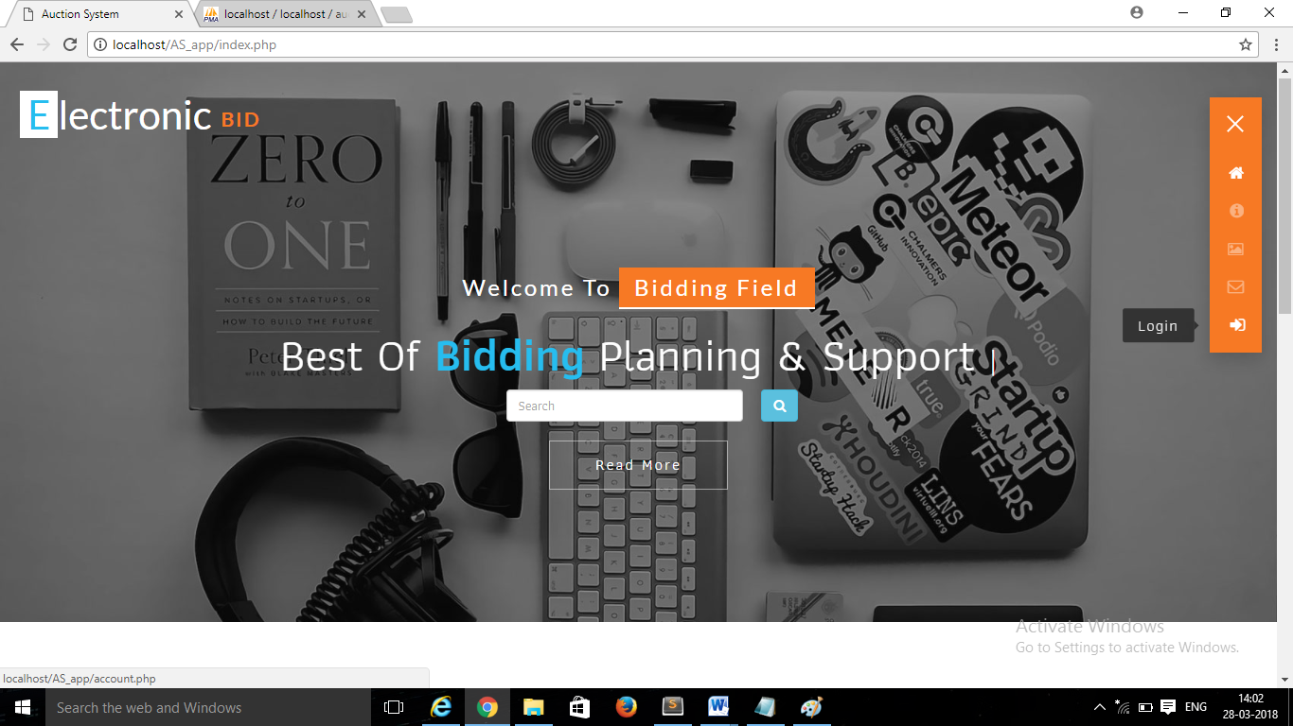

**Registration page**

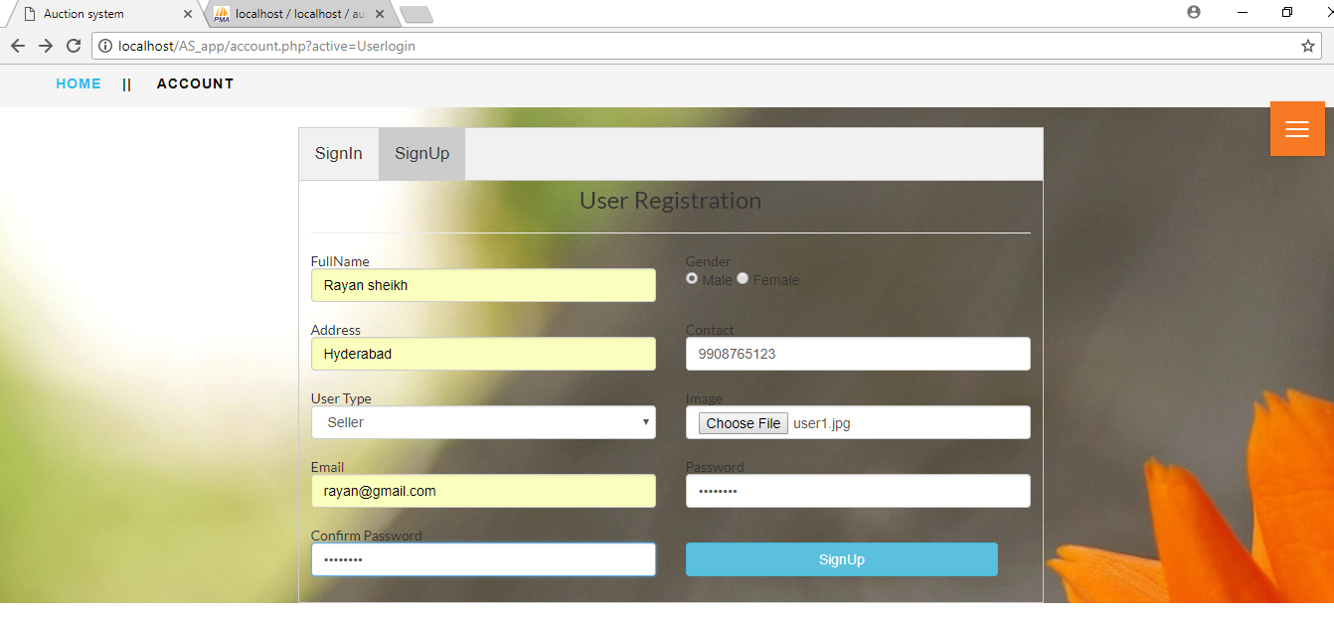

**Login page**

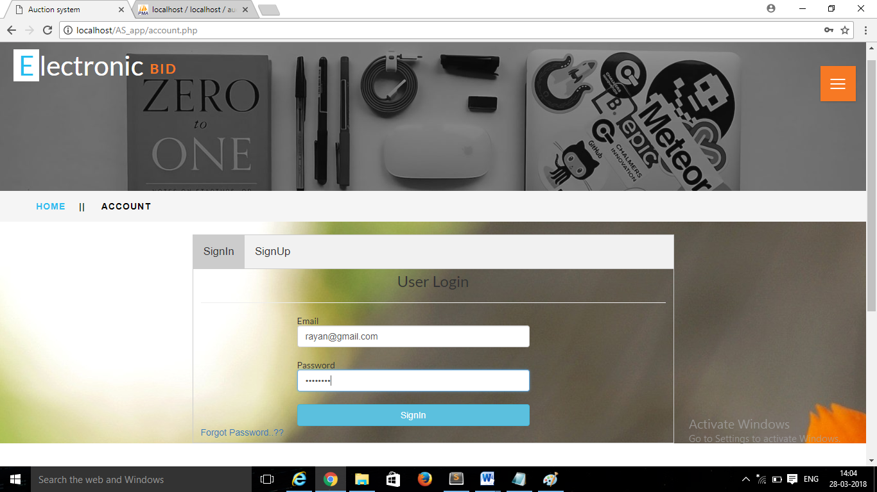

**Forgot Password**

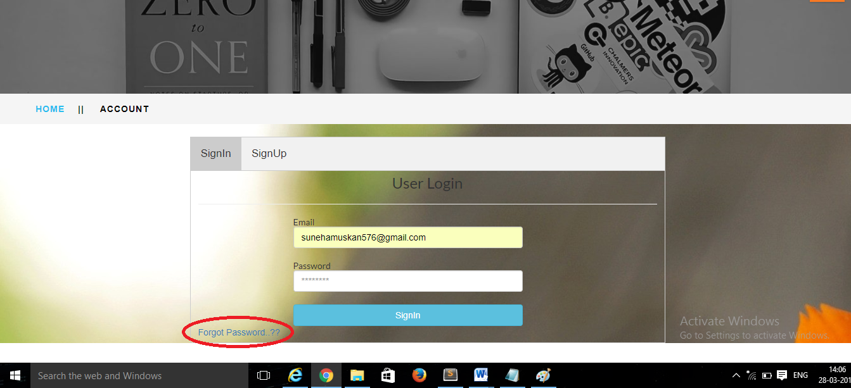



**Seller Dashboard**

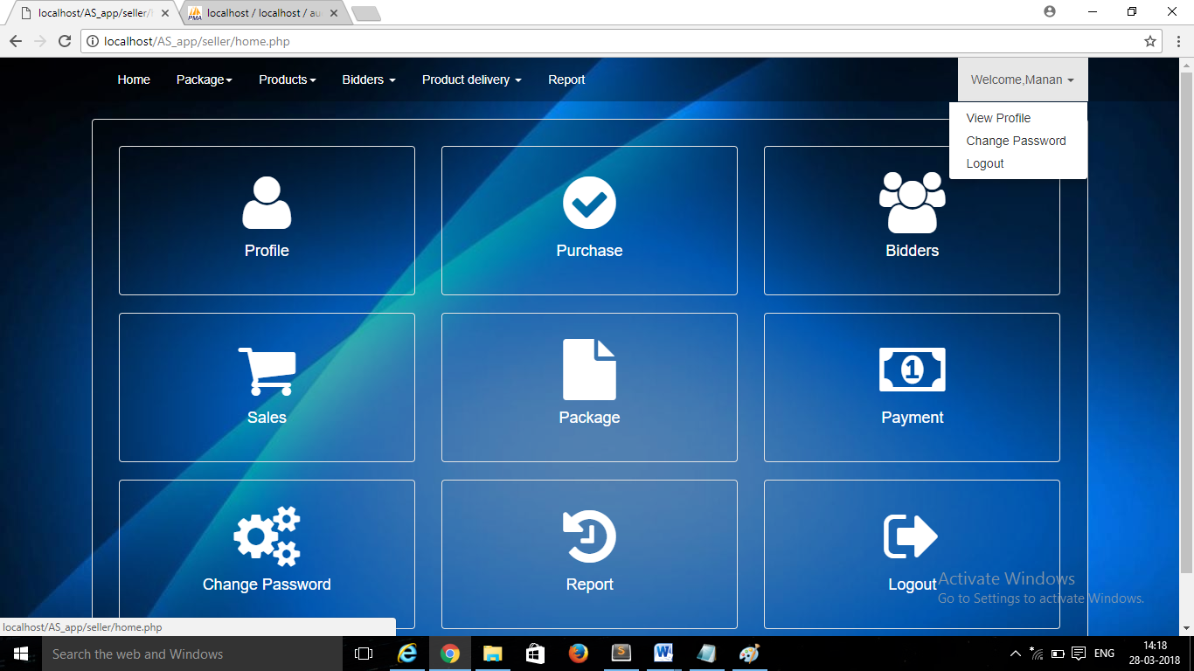

**View package**

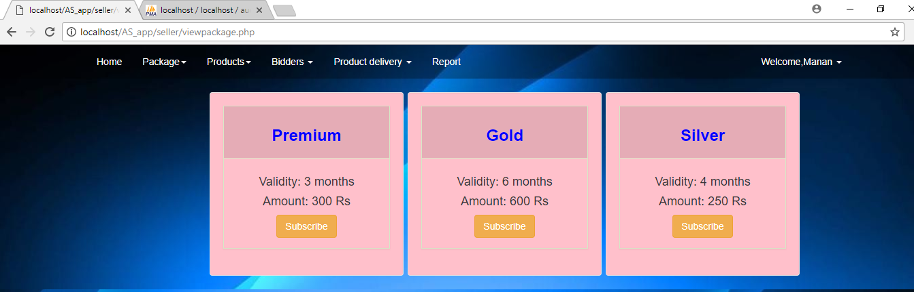

**Purchase package**

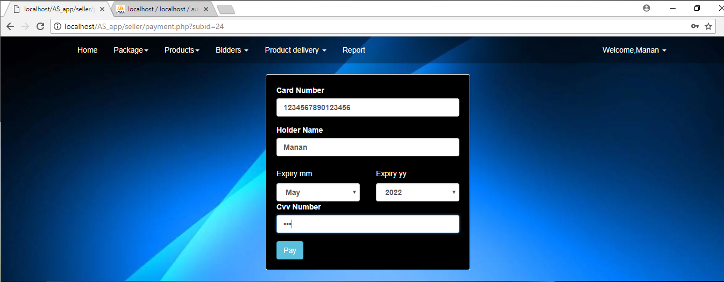

**Adding up an item**

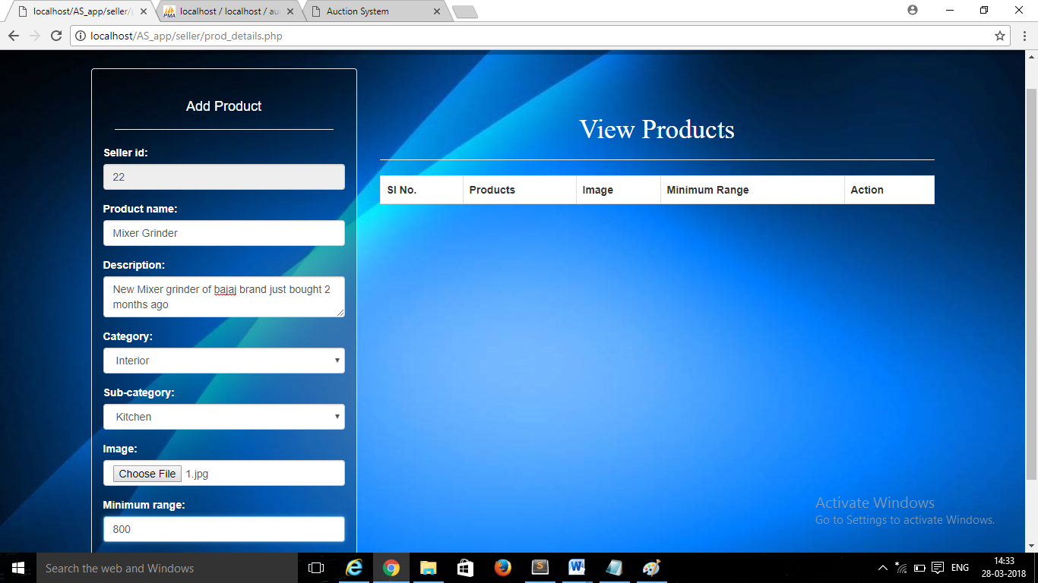

**Displaying the product**

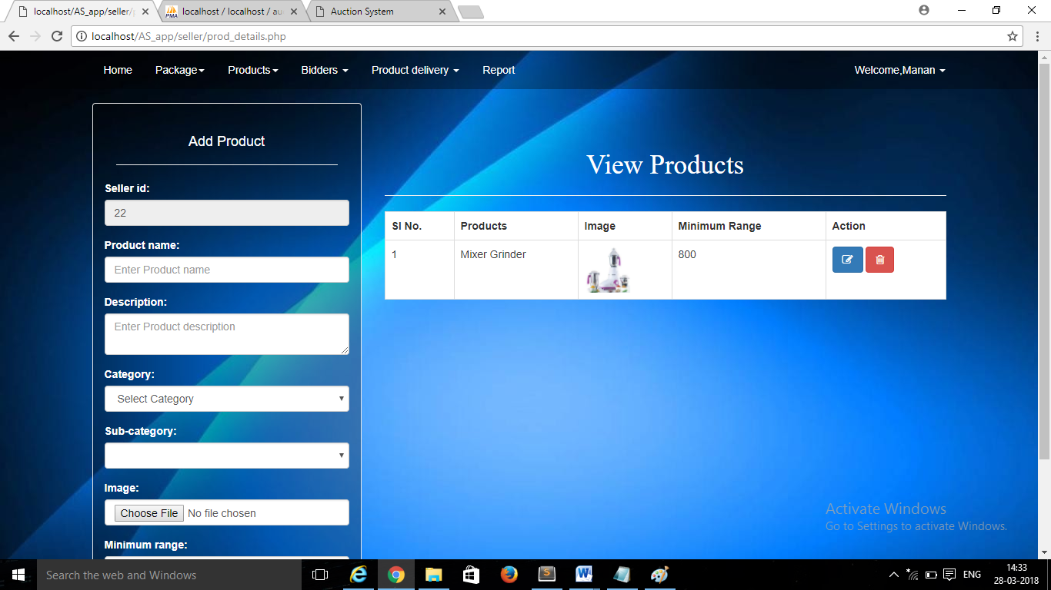

**Sending request to host the product** 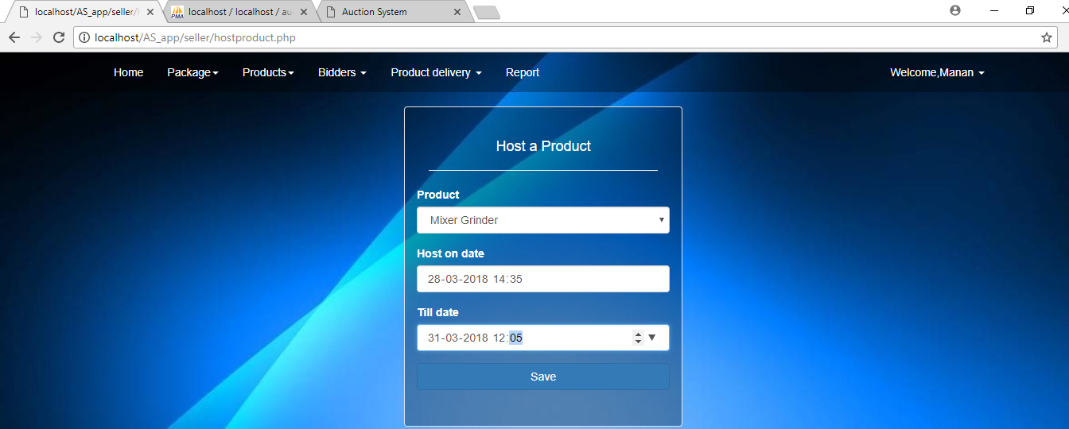

**View Bidders**

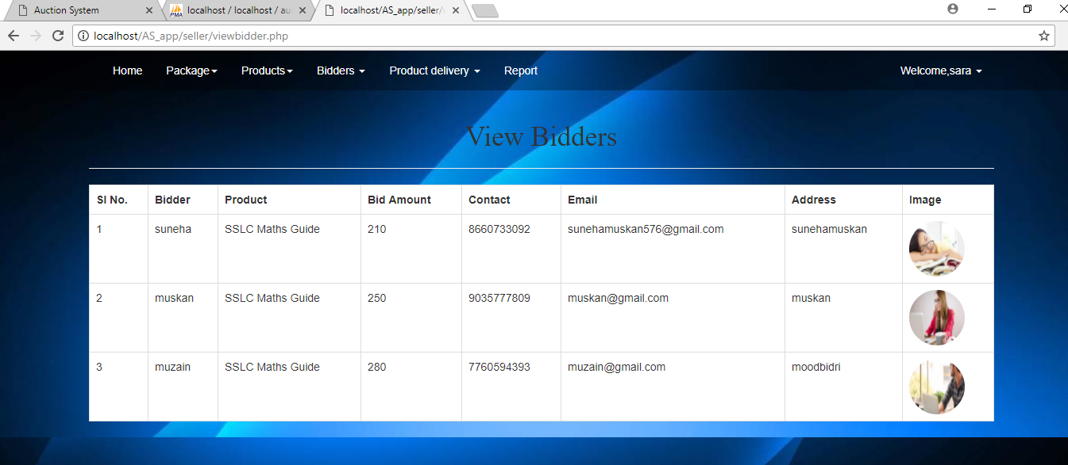

**Admin Dashboard**

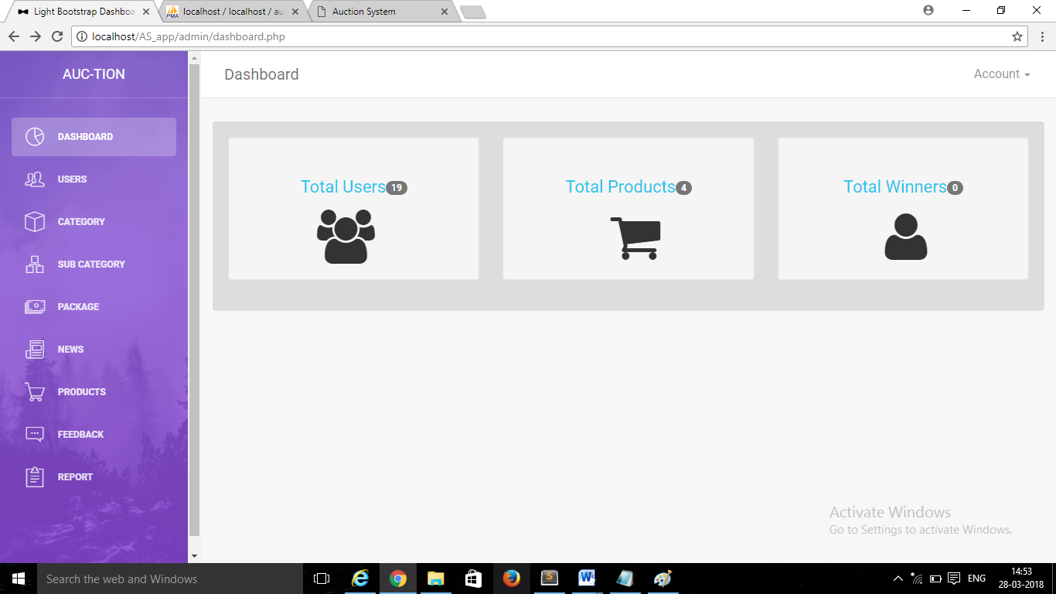

**Admin Hosting the product**

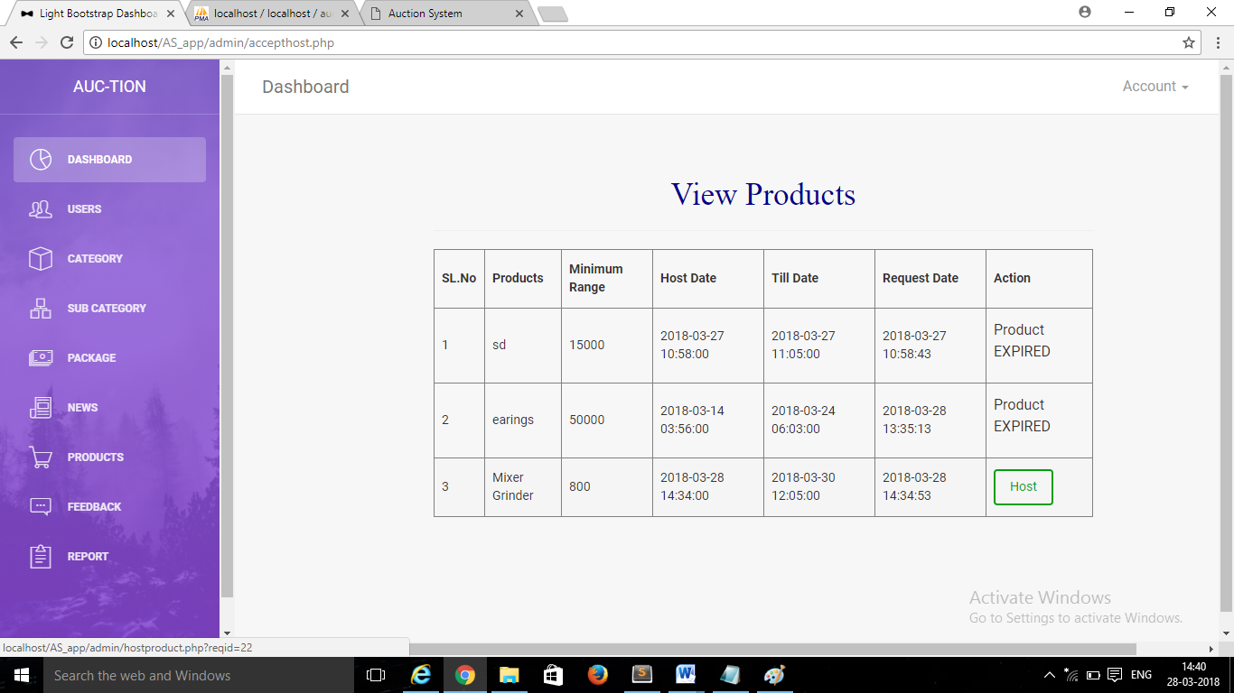

**Admin Hosting the news**

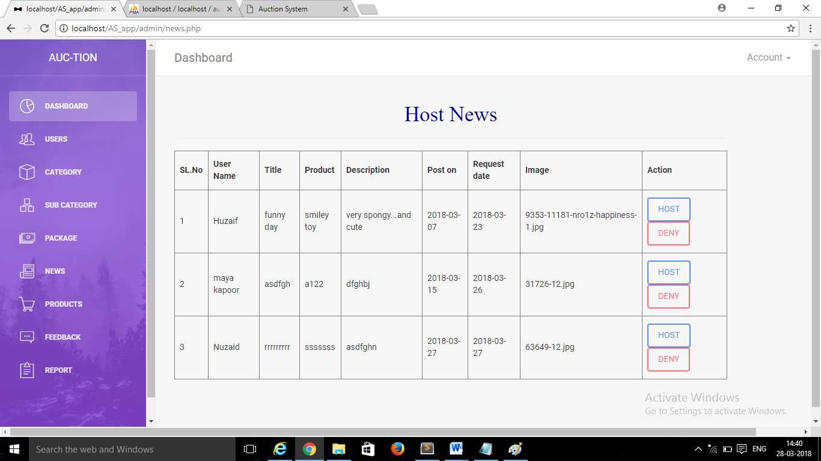

**Admin Viewing the feedback**

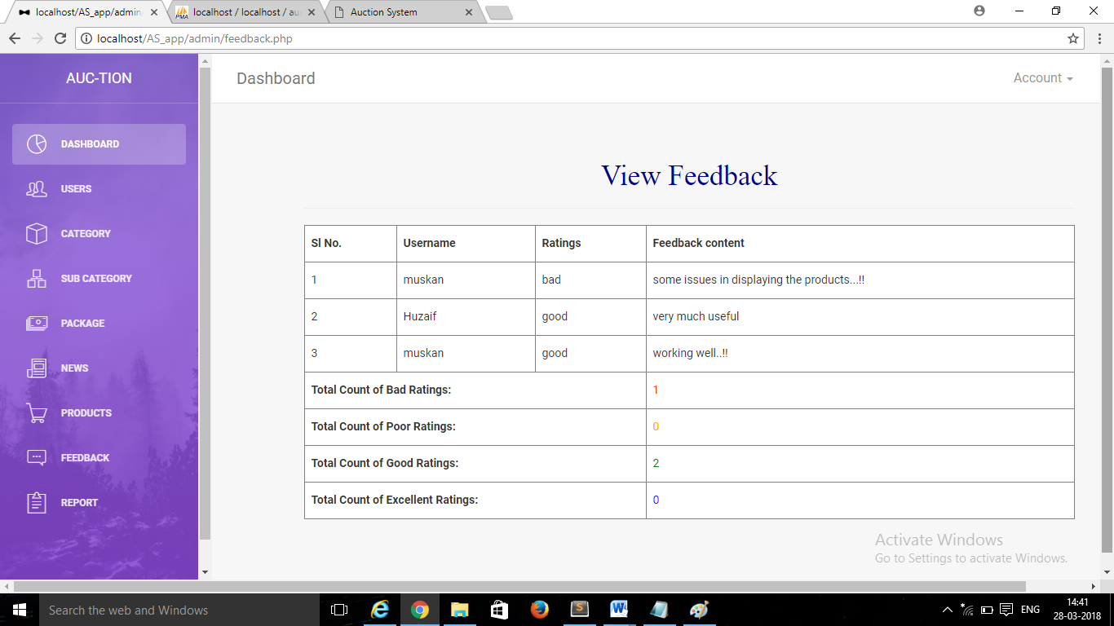

**Add Category**

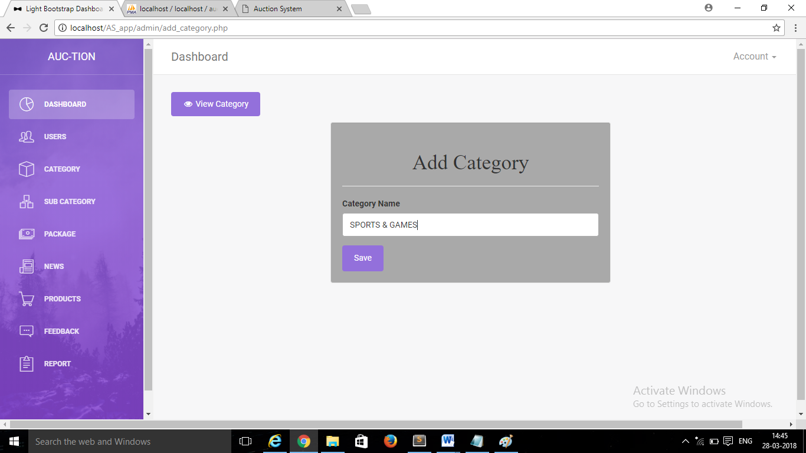

**Add Package**

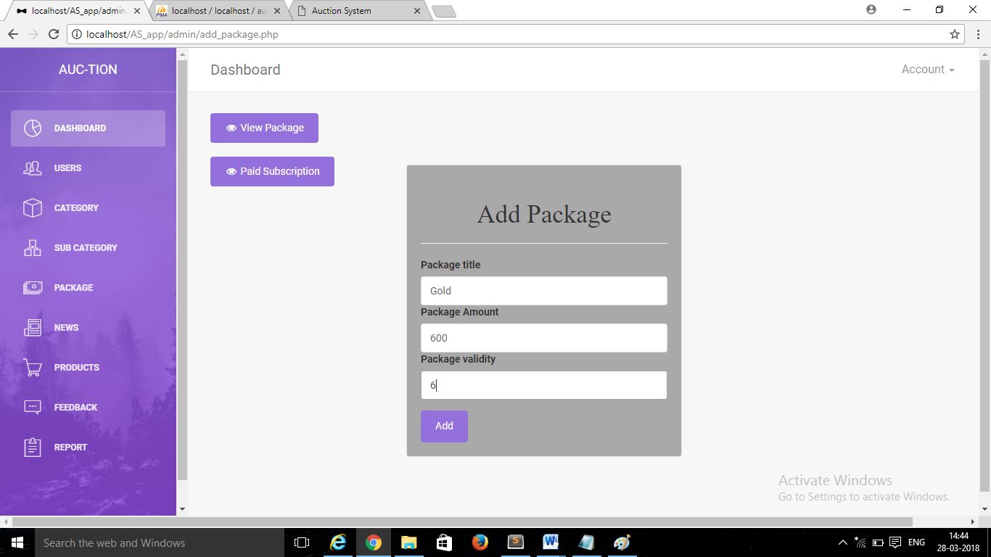

**Bidder page where the product are displayed**



**Bidding on an item**

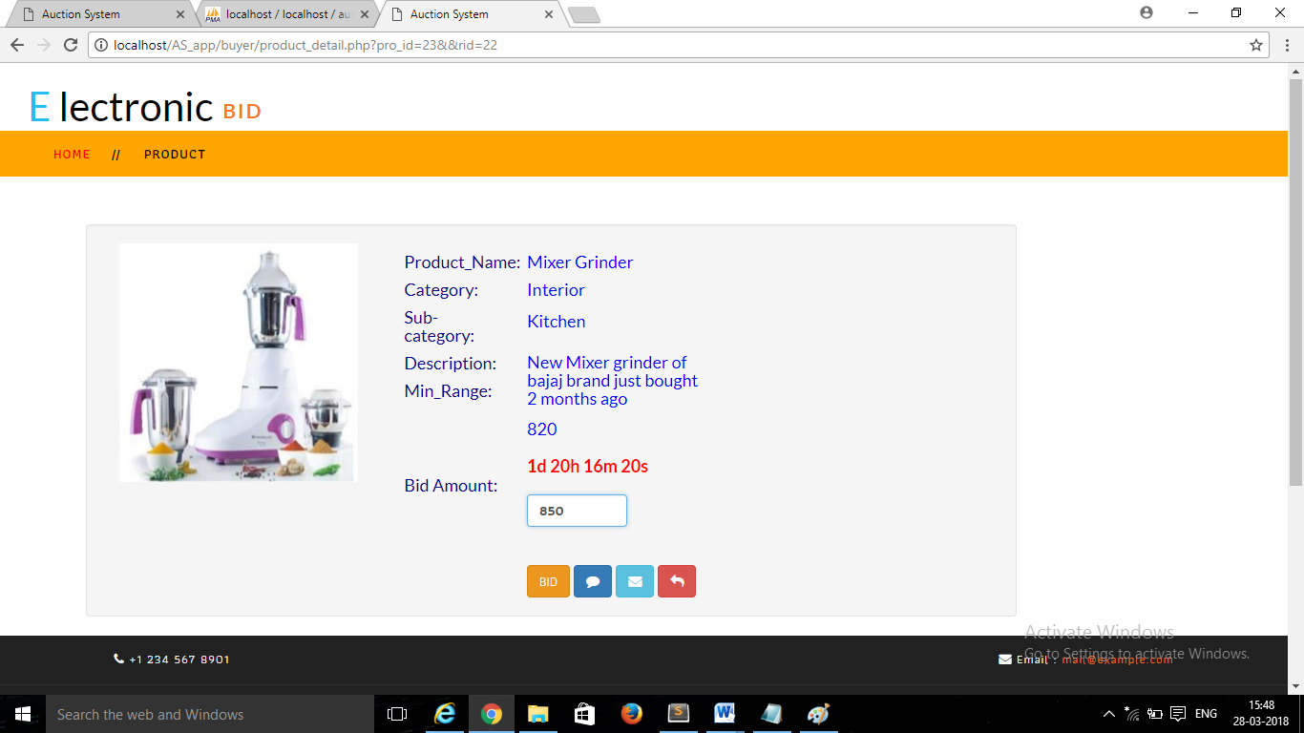

**Feedback Form**

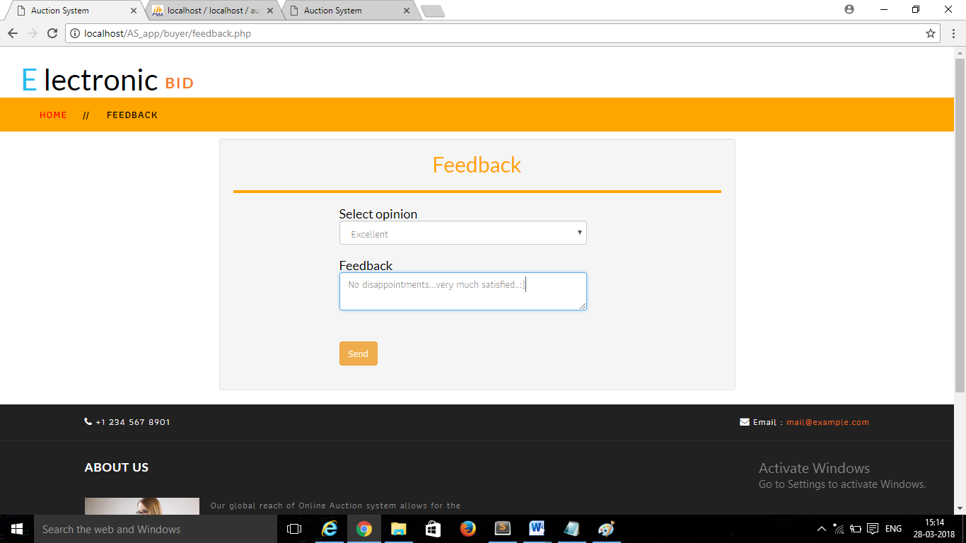

**View Profile**

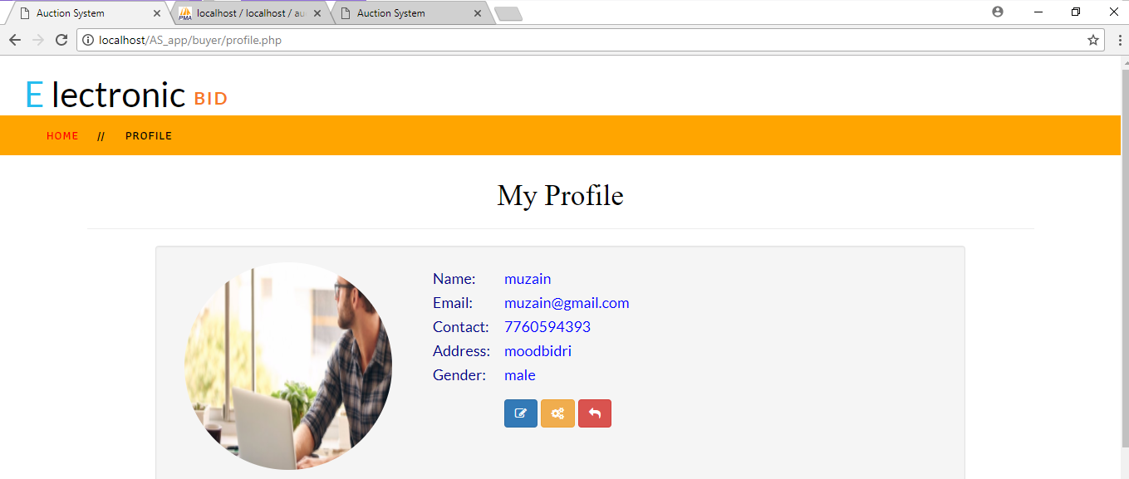

**Limitation**

**LIMITATIONS**

The Limitations of this website are as follows:

* Only registered users can do the auction in the website and can place bid on website
* User can only do auction on the given categories
* User cannot bid on the product less than that of the specified range
* User cannot create his own series of categories
* User cannot return the product if defected
* The System should be connected to the Internet.
* Cannot view the items in person and verify themselves the condition, colour and the size of the item

**Future Scope and Further Enhancement**

**FUTURE SCOPE AND FURTHER ENHANCEMENT**

* Information about shipping details.
* In Future we will browse many categories for auction.
* More genuine products will be sold.
* In Future this web application can be turned into a mobile application & shopping which is used in Mobile, Tablet and other technology devices.
* Change language option can be implemented
* In addition to English Auction, Reversed Auction can also be included
* Other than bid, Normal selling of the products will also be implemented

**Conclusion**

**CONCLUSION**

My project “ELECTRONIC BID” guarantees to simplify the intricate process of shopping. It promises great benefits to a user as it allows easy interaction, provide user friendly interface and reduces wastage of time. This system is extremely reliable and completely integrated so that we always know what we have in our hand and what is committed to the customer.

This project helped us to improve our knowledge in PHP. The importance of a good software design was learned during the project. I hope people find this software informative, useful, interesting and challenging. Developing the software was a good experience.

In the current scenario of software engineering, the software has to be simple, user friendly and should be able to incorporate any future improvement. This software facilitates all these features. The project was developed after extensive research conducted in a real life scenario which would exactly depict the present working condition.

The greatest strength of the project is its simplicity which enables an end user to study and use the utility in a full throttle. It has been a privilege for me to have an opportunity to implement this project.

**Bibliography**

**BIBLIOGRAPHY**

Book Referred:

The following books were referred during the development of the project

Author: Pankaj Jalote. An Integrated Approach to Software Engineering

Edition: ThirdEdition

Publishers: Narosa Publishing House, New Delhi.

**Database Management System**

Author: Ivan Bayross, Sql,PL/Sql

Edition: Third Edition

Publishers: BPB Publishers

**For Programming**

Author: Nixon (Robin), Learning PHP MySQL and JavaScript

Publication: Shroff publishers & Distributors Pvt Pankaj Jalote Ltd

**Websites:**

* [www.google.com](http://www.google.com)
* [www.w3schools.com](http://www.w3schools.com)
* [www.slideshare.com](http://www.slideshare.com)
* [www.ebay.in](http://www.ebay.in)
* [www.listia.com](http://www.listia.com)